**Design Template**

|  |
| --- |
| [Company] |
| Software Project Template |
| [Name of Project] |

|  |
| --- |
| [Student Name]  [Date]  [Version x.x] |

Contents

A. Introduction 3

A.1. Purpose Statement 3

A.2. Overview of the Problem 3

A.3. Goals and Objectives 3

A.4. Prerequisites 3

A.5. Scope 3

A.6. Environment 3

B. Requirements 4

B.1. Business Requirements 4

B.2. User Requirements 4

B.3. Functional Requirements 4

B.4. NonFunctional Requirements 4

C. Software Development Methodology 5

C.1. Advantages of the waterfall method 5

C.2. Disadvantages of the waterfall method 5

C.3. Advantages of {a different method} 5

C.4. Disadvantages of {a different method} 5

C.5. Best suited 5

D. Design 6

D.1. Storyboard or Flowchart (Change title to fit needs) 6

D.2. UML Diagram (Change title to fit needs) 7

D.3. GUI (Change title to fit needs) 8

E. Testing 9

E.1. Testing Type (change name to fit your needs) 9

E.1.1. Test Name 1 9

E.1.2. Test Name 2 9

E.1.3. Test Name 3 10

F. Sources 12

# Introduction

Provide a brief introduction to the proposed system. This section should be no longer than one paragraph.

# A.1. PUrpose Statement

Provide a brief overview of the purpose of this document.

# A.2. Overview of THE PROBLEM

Provide a brief overview of the problem that the proposed solution will solve.

# A.3. Goals and Objectives

Provide the goals and objectives for the project and solution.

# A.4. Prerequisites

Outline any aspects that need to be in place prior to the design, development, and implementation of the project proposed in this document. Be sure to be clear and concise for all listed prerequisites. Also, clearly outline why each prerequisite is needed.

*Note: If no prerequisites are needed, include a paragraph justifying why there are no prerequisites.*

|  |  |  |  |
| --- | --- | --- | --- |
| Number | Prerequisite | Description | Completion Date |
|  |  |  |  |
|  |  |  |  |
|  |  |  |  |
|  |  |  |  |

# A.5. Scope

Provide a brief overview of what the proposed solution will cover and what the proposed solution will not cover. It is important to set clear boundaries for the project.

# A.6. Environment

Describe the IT and hardware environments that the solution will be deployed in.

# Requirements

Provide a brief introduction on requirements. You may select the correct subsections that match the needs of your solution and the key requirements that you identified from the profile document.

*Note: All requirements must be in your own words and interpret the requirements found in the “CRM Requirements” attachment. Please do not copy and paste word for word from the requirements in the “CRM Requirements” attachment.*

# Business Requirements

Provide a brief introduction to the business requirements for the proposed system.

# User Requirements

Provide a brief introduction to the user requirements for the proposed system.

# Functional Requirements

Provide a brief introduction to the functional requirements for the proposed system.

# NonFunctional Requirements

Provide a brief introduction to the nonfunctional requirements for the proposed system.

# SOFTWARE DEVELOPMENT METHODOLOGY

The company has selected the waterfall software development methodology for this project. Examine the waterfall methodology and compare it to other software development methodologies (e.g., Agile). Include a brief introduction to the development process as well.

*Note: All subsections are required. Refer to the requirements section and rubric section of the assessment for additional information.*

# Advantages of the waterfall method

Describe the advantages of the waterfall methodology and how they will benefit this project.

# disAdvantages of the waterfall method

Describe the disadvantages of the waterfall methodology and how they may hinder this project.

# Advantages of {A DIFFERENT METHOD}

Describe the advantages of a different methodology and how they will benefit this project.

# disAdvantages of {A DIFFERENT method}

Describe the disadvantages of a different methodology and how they may hinder this project.

# best SUITED

Describe why the waterfall methodology is the best software development methodology for this project.

**OR**

Provide the details of a different development process and outline why you would have selected it and how it would have been better suited for this project.

# Design

Provide a brief overview of the proposed design.

*Note: These subsections may be copied, rearranged, and modified to fit the needs of the solution. At least two visual representations of your design need to be present.*

# Storyboard or Flowchart (Change title to fit needs)

Provide a storyboard or flowchart of the application.

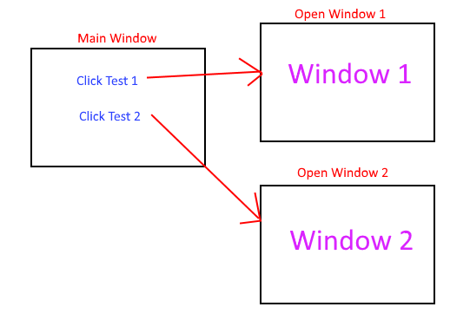

Figure : Sample Storyboard

# UML Diagram (Change title to fit needs)

Provide a set of UML diagrams that cover the proposed solution. This can include but is not limited to class diagrams, database diagrams, and use case diagrams. Also, ensure that all diagrams are clearly discussed and noted.

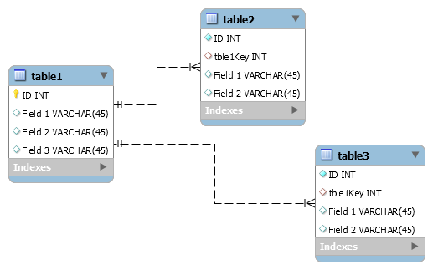

Figure : Sample Database

# GUI (Change title to fit needs)

Provide a mock-up of the proposed GUI forms that will be used in the proposed solution. Also, clearly indicate where the GUI components point inside the application.

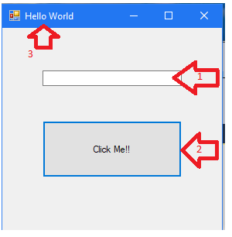

Figure : Sample GUI Mock-up

|  |  |  |  |
| --- | --- | --- | --- |
| GUI Control Mapping | | | |
| ID | Control | Property | Data Source |
| 1 | Textbox | On application open text = “” or null | NA |
| 1 | Textbox | On click of button text = “Hello World” | Internal Variable |
| 2 | Button | On click change text of textbox 1 to “Hello World” | Internal Variable |
| 3 | Form | Text= “Hello World” |  |

# Testing

Provide a brief introduction to the proposed testing solution. The tests need to be from 3 completely different functionality aspects. Testing the same aspect with slightly different criteria is not acceptable.

**Note: *Add and remove subsections as needed to cover all the testing needs.*

# Testing Type (change name to fit your needs)

Provide a brief introduction paragraph.

# Test Name 1

|  |
| --- |
| Requirement to be tested |
| Preconditions: Conditions that must be present before test case can successfully run |
| Steps: The steps the tester must execute to test the feature. |
| Expected results: Expected results and any side effects such as updating a database, writing to a file, etc. |
| Pass/Fail: Mark whether the test case passed or failed. The results can be compiled and used to determine if the application is ready for delivery/release. |

# Test Name 2

|  |
| --- |
| Requirement to be tested |
| Preconditions: Conditions that must be present before test case can successfully run |
| Steps: The steps the tester must execute to test the feature. |
| Expected results: Expected results and any side effects such as updating a database, writing to a file, etc. |
| Pass/Fail: Mark whether the test case passed or failed. The results can be compiled and used to determine if the application is ready for delivery/release. |

# Test Name 3

|  |
| --- |
| Requirement to be tested |
| Preconditions: Conditions that must be present before test case can successfully run |
| Steps: The steps the tester must execute to test the feature. |
| Expected results: Expected results and any side effects such as updating a database, writing to a file, etc. |
| Pass/Fail: Mark whether the test case passed or failed. The results can be compiled and used to determine if the application is ready for delivery/release. |

# Sources

Place the sources that you used here.

*Note: See the sources section in the requirements and rubric. If you did not use any outside sources, you may delete this section.*